Towercom

Radix High Level Design (HLD)

Contents
Introduction 4
Purpose 4
Required Modules and Functionalities 5
System Views 5
Modules 5
User Groups 14
Security 16
Phased Approach 16
Environments 16
Other Requirements 16

Introduction
Towercom currently uses its bespoke application called Radix. It is an asset management/workflow tool for its telecoms infrastructure portfolio in Ireland.
The application is used to run Towercom’s day to day business by internal company users and with interaction of external users, such as Customers (Operators) or the Operator’s Contractors.
The tool is approx. 10 years old and has been written in Kohana PHP with a MySQL database in the background; as such it is nearing end of life and does not have all the required functionality to support a number of new business activities. Therefore, Towercom is looking to find a suitable replacement which can cover current functionalities along with enhancements and new project/activity requirements. There is also a requirement for data migration from the existing system to the new solution.

Purpose
The purpose of this document is to provide a high-level description of existing Radix functionalities and the additional business requirements for assessment by potential tenderers.

Required Modules and Functionalities

System Views
Towercom will require 2 types of view for the data stored in the system: enterprise and site. These 2 views will present the data in different way, with the enterprise showing usually a list of items with possibility to expand for more information and the site view having details for the site-specific information for various modules.

Modules
Below is the list of required modules.
Main modules/functions:
- Dashboard
This will be a landing page for system users. It will have a different look/content depending on the user type.
Users will see an overview of activities relevant to them which will include charts and/or tiles to allow them to interact with and progress projects.
For example, a customer (operator) user will see an overview of all mast space applications (which we call SRFs) and the stage these are at in the workflow. A contractor user would have a different view, for example they might see an overview of all site access/job applications (SAFs) as well as the accreditation status (including soon expiring certs and permissions) for their crew members. Click through from the lists/tables will allow the user to interact with the data and perform actions relevant to that workflow.

- Site Locator
This feature consists of an interactive map and lists identifying the asset locations with the ability to search by various (multiple) criteria, such as county, structure or asset type, etc. User has the ability to click on a selected site/asset from the returned list to access more detailed asset information or perform and action workflows such as create a new space request, set up a new job card, book access etc.

- Site/Asset Information
The system must be capable of storing a range of asset information and allow users to view and update/amend this (subject to predefined permissions/user levels i.e. contractors will be able to view basic asset information such as location and access information but will not have visibility of maintenance schedules, portfolio details etc). The data is generally static in nature e.g. co-ordinates, address, property folio details, directions to site, structure type/height/other properties.
Data will be held on a per asset basis, under various section headings/disciplines; the data may be copied from/linked to other modules. The main areas being:
- Estates – to include title/folio, town planning, head lease, right of way and wayleaves
- Facilities – to include indoor/building accommodation, power/electrical, fibre/utilities, air conditioning, fire extinguisher and alarm/security systems
- Structural Engineering – to include engineering properties, structure capacity and loading details, climbdown/inspection records
- Asset Photos & Record Drawings – to include layout plans, space allocation drawings/models, panoramic photos as well as elevations; if possible we would like the system to link directly to BIM/Revit or 3D models of the assets, so that the user can view available space – thus aiding the SRF workflow.
- Asset Safety Files –this will contain safety-related information; examples being: drawings, forms and reports, either to be uploaded to the module, or forms and reports created for use in the module. Information may be copied from/linked to other modules and data, e.g. Fall Arrest System details, last inspection dates, next inspection dates, or new information, e.g. inspections, surveys and reports (ACM, EMF, etc.).

- CRM / User Profile Management
List of Companies (Customers/Operators, Contractors) and related Profiles/Users. This module will be used for creation/administration of all system users (company and individual): 1) Towercom users, 2) Customer management (“Licenced Operators” who will be permitted to install on our asset) and 3) Contractor management (“Accredited Contractors” that are permitted to work on our sites, either as a Towercom contractor or an Operator sub-contractor).
To effect requirements, the module must be capable of:
- recording basic company information such as registered number/address, nature of system use (i.e. contractor, customer, both)
- selection of the nature of works, portfolio or sites that access can be granted for, and principle/sub-contractor status
- links to Licensed Operator information and Accredited Contractor information held in other sections, as applicable

- Customer Licensing & Contractor Accreditation Agreements
This module contains a tabular executive summary of the customer/contractor framework agreement(s) and holds the customer licences (SDS) and Company Accreditation Details Sheets (CADS) which are generated via the SRF and accreditation workflows respectively.
The agreement summary includes information which will automatically be pulled into the individual SDS when this is being created; other information such as term, fee review etc will be used for contract and customer relationship management.
The SDS includes: 1) details of the installation – licenced/installed equipment, utilities details, pre-install works, 2) copy of agreed drawings, 3) licence fees - including any changes/updates and 4) any applicable conditions.
SDS are licences which sit under a framework agreement with each customer; CADS are a schedule to an accreditation/service agreement with contractors. In both cases these are signed online; a PDF of the final executed version will be emailed to the customer as well as being available to view/download within the system.
Towercom requires the ability to add/edit customer/contractor agreements and to create/change the SDS/CADS template on a customer by customer, portfolio by portfolio basis.
Billing cycle information from the agreements will be matched to data in the relevant workflow for billing purposes. The system should therefore have the capability to generate billing files (annual, bi-annual and quarterly cycles) and link to a 3rd party finance application (currently Sage but most likely replaced with Oracle NetSuite / MS Dynamics ).

- Trouble Tickets (TT)
This module is used to log, manage and resolve issues found on sites. It allows TTs to be categorised, prioritised and assigned to an owner (TT’s may be assigned to a Customer or Contractor user as well as a Towercom user). A TT can also be linked with the Job Card module (see below); there will be different workflows for different type of tickets.

- Inventory
This will be a list of all equipment (licenced or installed) on each site, which can be filtered by operator. Inventory records are updated based on an approved and/or licenced SRFs (upon execution of an SDS). To maintain the integrity of the site licence process, the inventory cannot be updated or changed without an approved SRF and executed SDS.

WORKFLOWS: primary workflows as outlined below. Towercom requires the ability to create/change its own workflows.
- Site Access (SAF) Workflow
This module will be used to book and manage all site access activities i.e. site visits/works on each site.
Booking access is based on a simple workflow process, that includes various validation criteria (e.g. timeblock availability, accreditation status, site visit type and link to an executed SDS). Under certain circumstances, the system may auto approve a request once certain conditions have been met.
In addition to the validation criteria, before approval, the SAF will be verified against 1) approved SRF/SDS and 2) Accredited Contractor list.
Users will have the option of selecting pre-approved standard documents or uploading booking request specific documents at submission stage. Additionally, handover/completion documents will be uploaded to the SAF upon completion of works/access to close out the SAF.
Email and system/app generated notifications for the requestor are required.
Towercom requires functionality, particularly within the mobile app to track real time/date of entering and leaving the site by crews. Additionally, the system should be capable of interfacing with a 3rd party access control system application.
Towercom will require a calendar view with blocks availability for each day on each site.
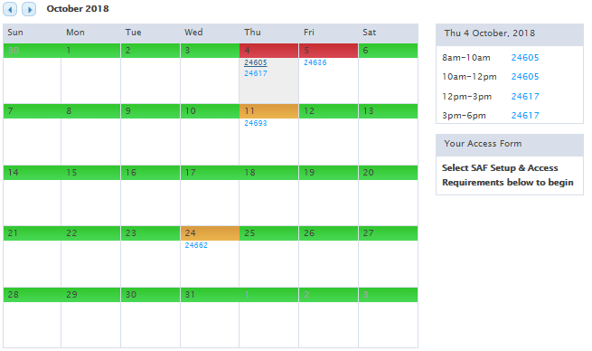
The days will be colour coded depending on number of timeblocks used.
- Red colour on the calendar indicates no available timeblocks on that day.
- Amber shows that there are some timeblocks already booked but there is at least 1 free.
- Green shows that all timeblocks on that day are free.
Towercom users will be able to see SAF numbers on the calendar regardless of customer accessing the site. Customers or contractors will only be able to see colours on the days and whether the timeblock is available or not unless the SAF has been logged by them.

- Space Request (SRF) Workflow
This workflow manages an operator’s request for adding, changing or removing equipment on the site. It will include various steps to be actioned by both Towercom and users within the requestor organisation, with different user permission levels applicable to approval/sign-off steps.
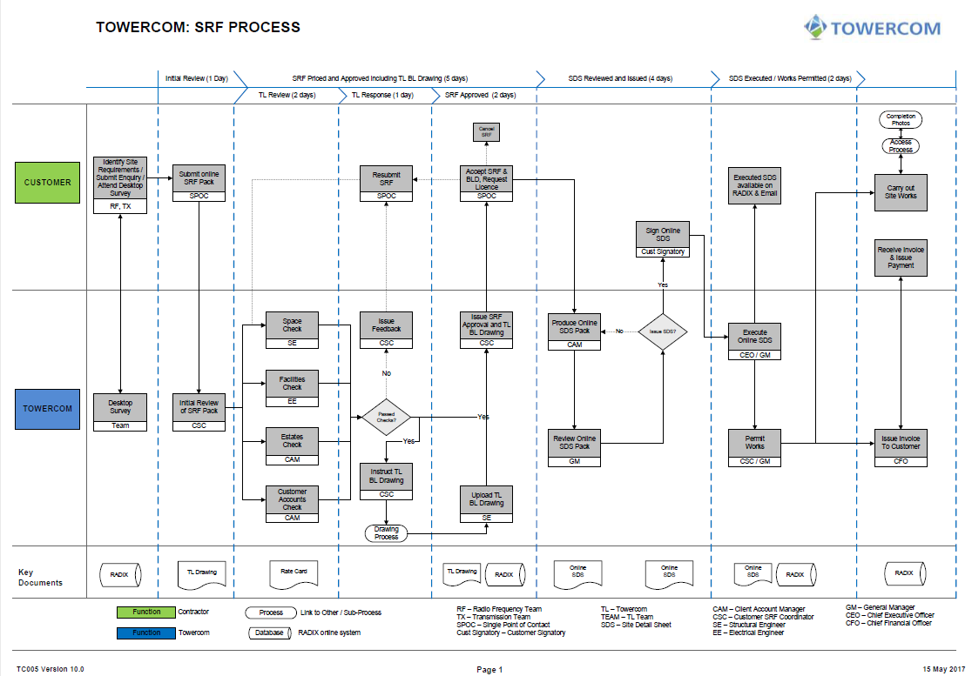
There are 3 elements to the Space Request:
- Initial request and reaching agreement of positions/heights and any applicable conditions
- Licencing of the Space – these are the steps which generate the SDS (see above).
- Works completion and inventory update – the site inventory is updated as the SRF moves through the workflow (e.g. licensed, installed, proposed remove); upon receipt and verification of handover/completion documents the inventory is updated and final SRF steps are closed off.
Validation criteria built into the workflow will include timeouts for completion of the works and functionality to effect contract notice periods. Where works are not completed within set durations Towercom will be able to issue a reminder to the customer and thereafter have the option to roll back the SDS/inventory to the previous status.

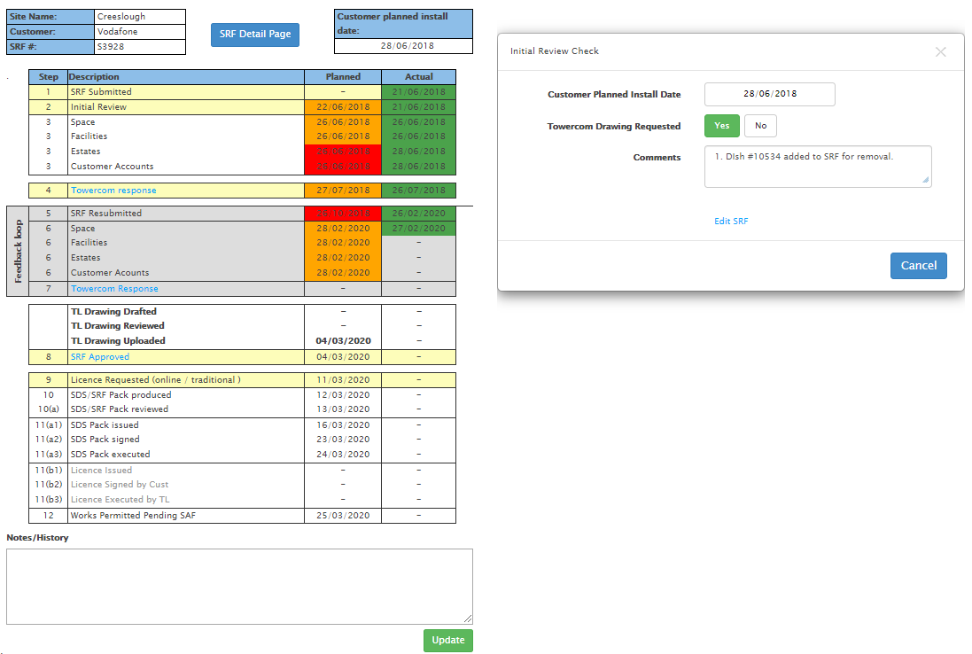

- Job Card Workflow
This workflow allows a job card to be created out of: 1) SRF Workflow (typically jobs required to facilitate a customer installation), 2) Trouble Tickets review (arising from climbdown inspection or reported issue), 3) Planned Works (by reference to the asset inspection records) or 4) by manual entry.
Each job card will have defined milestone tasks to allow tracking and forecasting of activities to complete the job.
Blocks of tasks will be defined around required activities e.g. Site Acquisition, Planning, Design, Power, Construction, Site Handover/Inspections. Some jobs will require multiple blocks of tasks to complete, for example a tower extension job will require the following blocks: Planning, Design and Construction.
Forms and templates required by steps in the process (e.g. site inspection, site survey) should be available to fill in/upload via the system and available for completion in the mobile app.
The system should have the ability to assign jobs to internal personnel and external contractors.

- Accreditation Workflow
Accreditation is the process for verifying and checking details/certificates of any party who wishes to access or carry out works on a Towercom site. To administer this process 2 workflows are required.
Firstly, a workflow that handles the Company Accreditation, which is renewed on an annual basis. A pre-defined application form is completed and list of documents uploaded by the Company seeking accreditation.
Upon successful application Towercom will issue, via the system, a Company Accreditation Details Sheet (CADS) which confirms information such as: the type of accreditation, approvals given, any conditions and the duration of the accreditation.
Similar to the SDS, a CADS is signed online and a PDF copy is emailed to the Company with the document being available to view/download directly from the system.
Second is a workflow that processes individual engineer/crew member accreditation details, applicants complete an accreditation application form and upload certs (e.g. climb & rescue, rooftop training).
Towercom will select the nature/scope of accreditation granted based upon the information provided. The system will generate an email confirming successful application and status, expiry etc will also be available to view online.
Inbuilt validation criteria will alert users to certs which are soon expiring and the system will automatically restrict accreditation upon expiry of certs, pending confirmation of renewal.
Reporting Module
A robust interactive reporting module is required with both graphical representation on all business data as well as detailed list type reports that are easy to use and link to relevant data in the system. A suite of pre-defined reports should be available, the user should have the ability to access reports relevant to their user type and be able to filter/adjust the data on screen. Towercom administrators require the ability to change/create new reports and publish these to users.

Other modules/features
- In Built Help/User Manual
Towercom would like an in-built user manual/help module to help users understand the system quicker. That could include pop up information explaining fields, actions, steps for users depending on user type.

- Mobile App
Towercom requires a mobile app for core features/modules to be available along with the new system. This would be aimed predominantly at field-based users and those on-the-go.
Would include ability for user to update tasks complete, upload photos and videos, and record any further follow up work required

User Groups
The current system has 3 groups of users (Towercom, Customer, Contractor) with various levels of permissions relevant to their role.
It is anticipated that these 3 user groups will remain the same; but that sub-user groups will be redefined to reflect the level and scope of the roles required to properly implement a new system which meets the requirements outlined above.
The type of sub-user groups which will need to be catered for are described briefly below.
- Towercom – this group will have the highest visibility of records across the system.
  - TL Basic – this will be a basic user type with the ability to process workflow tasks and perform day to day activities.
  - TL Super User – this will be a medium level user with expanded permissions, for example allocating jobs, billing and contract management etc.
  - TL Signatory – this user will have all permissions including signing agreements/contracts.
  - Administrator – this user will have permissions above (except contract signing) as well as the ability to create/manage workflows, reports etc.
- Customer – these are licenced operators that are installing equipment on Towercom sites.
  - This group will only be able to view records relating to their company.
  - Sub-user groups with the Customer area will be required to cater for: Signatories, Administrators (raising & monitoring requests) and Field Operations
- Contractor – these are the companies performing work on behalf of Towercom or an operator customer.
  - Their permissions will cover records related to them and the customer they perform the work on behalf of (as set in the Accreditation workflow/CADS).
  - Contractors will require logins for: signatory, administrators/PICW and field-based staff (many of whom will typically have very limited interaction with the main system but will require access to the mobile app for safety and sign-in/out type activities).

Security
Towercom requires the replacement system to follow latest Cyber Security standards.

Phased Approach
Towercom can agree, depending on presented plan, to implement the new system in Phases. This will be dependent on content of each phase and proposed suitable solution in the interim.

Other Requirements
- Project Management function to schedule and run projects across multiple sites/locations/customers
- Forecasting capabilities on projects for future tasks (ie Task/Milestone + x days etc)
- Timesheet recording of effort against projects / tasks
- Pricing – once SRF (space request) is lodged by customer, it would look up rate card and based on parameters/rules and what equipment is already installed, it would prepare a quote to the customer (which would be checked/amended as required internally)
- Invoicing – automatically generate billing based on customers MSLA pricing.

